**4. Discuss Ingress Importance of Rules ordering**

**Test Order in Context path-based routing**

--- **Important Note-1**: In path based routing order is very important, if we are going to use "/*", try to use it at the end of all rules.

--- Move Root Context Path to top and see what happened.

--- File: 04-ALB-Ingress-ContextPath-Based-Routing.yml

  ingressClassName: my-aws-ingress-class   # Ingress Class

  rules:

    - http:

        paths:

          - path: /

            pathType: Prefix

            backend:

              service:

                name: app3-nginx-nodeport-service

                port:

                  number: 80

          - path: /app1

            pathType: Prefix

            backend:

              service:

                name: app1-nginx-nodeport-service

                port:

                  number: 80

          - path: /app2

            pathType: Prefix

            backend:

              service:

                name: app2-nginx-nodeport-service

                port:

                  number: 80

**Deploy Changes and Verify**

**# Deploy Changes**

--- **kubectl apply -f kube-manifests/**

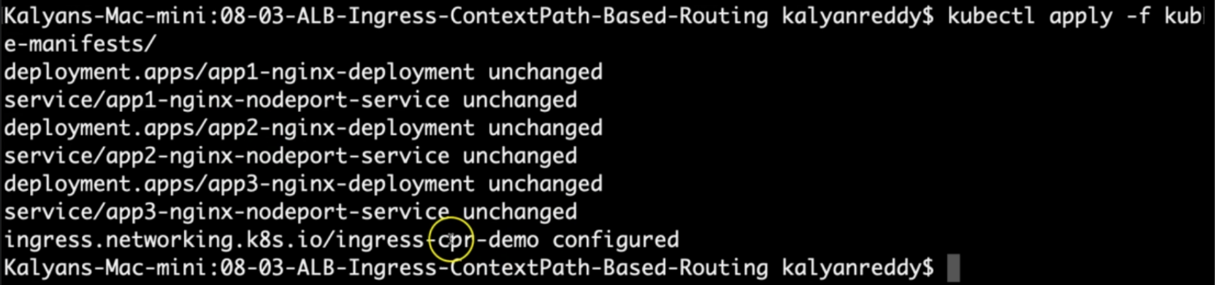

--- for ingress, there is configuration.

--- go to the load balancer.

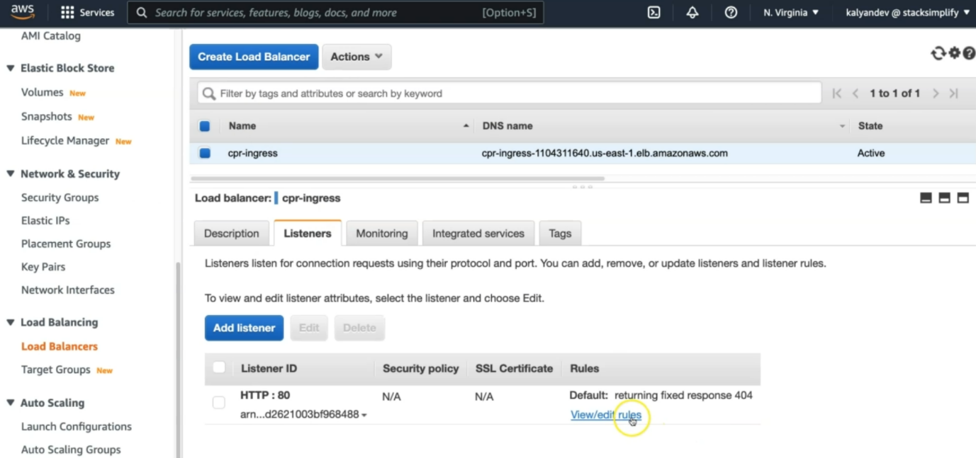

--- click on the view/edit rules.

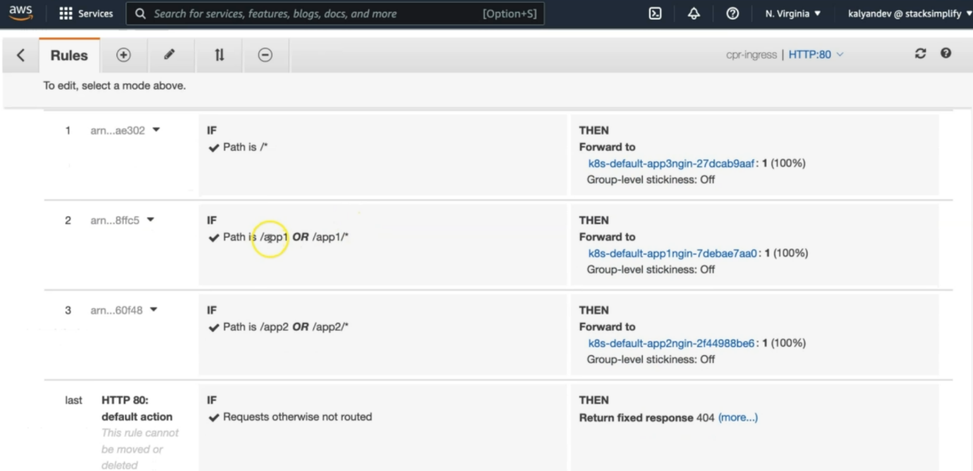

--- **note** - earlier /app1/* is at the top place but now /* (root context) is at the top place so, the routing for /app1/* and /app2/* will fail.

--- this is because /app1/* and /app2/* are part of the /*. So this is why we cannot define /* at the top.

**# Access Application (Open in new incognito window)**

--- **http://<ALB-DNS-URL>/app1/index.html -- SHOULD FAIL**

--- **http://<ALB-DNS-URL>/app2/index.html -- SHOULD FAIL**

--- **http://<ALB-DNS-URL>/ - SHOULD PASS**

--- **Roll back changes in 04-ALB-Ingress-ContextPath-Based-Routing.yml**

spec:

  ingressClassName: my-aws-ingress-class   # Ingress Class

  rules:

    - http:

        paths:

          - path: /app1

            pathType: Prefix

            backend:

              service:

                name: app1-nginx-nodeport-service

                port:

                  number: 80

          - path: /app2

            pathType: Prefix

            backend:

              service:

                name: app2-nginx-nodeport-service

                port:

                  number: 80

          - path: /

            pathType: Prefix

            backend:

              service:

                name: app3-nginx-nodeport-service

                port:

                  number: 80

**Clean Up**

**# Clean-Up**

--- **kubectl delete -f kube-manifests/**